1. 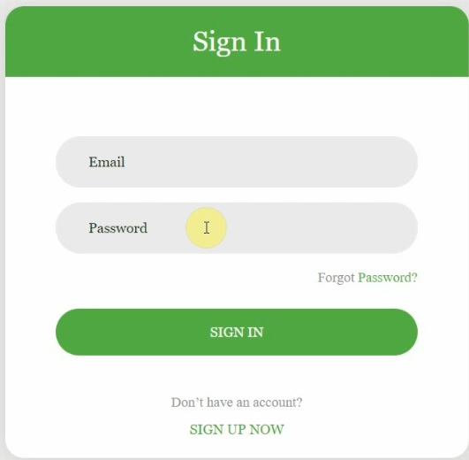
2. Going to introduce Front-App UI developed in Angular and would be shared with Github Link.
3. Don’t worry about the Front-End Code.
4. This is banking app as security is most important aspect in banking domain.
5. See, the very first landing page that the customer of a bank will be shown is a login page.
6. We will authenticate and authorize the user logging with a back-end service leveraging this spring security frame.
7. 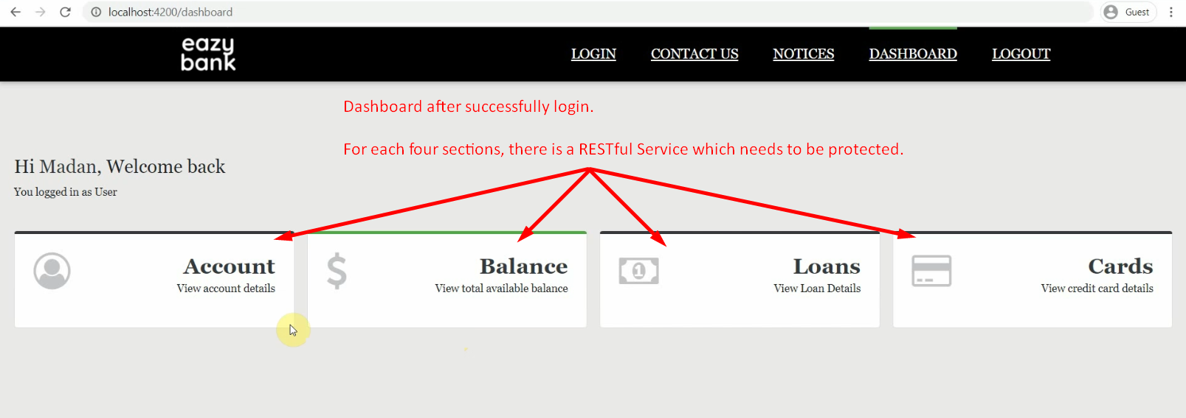
8. 